PickNKick Visual Branding Inspiration

Typography & Wordmark
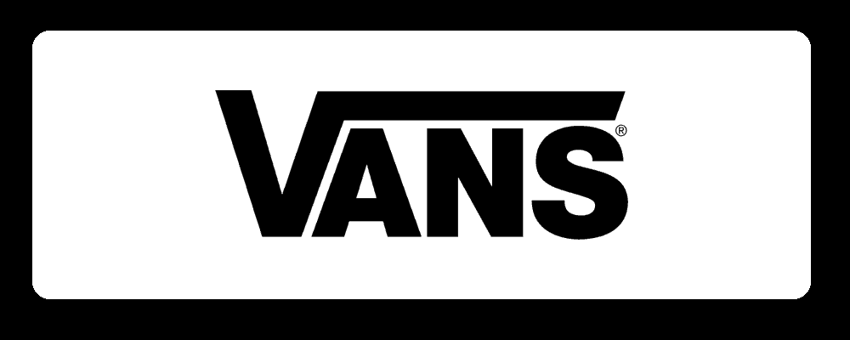
Example: The Vans logo stretches its “V” forward to imply motion, and Casper adds a curled flair to its “C,” showing how a subtle custom tweak can make a wordmark distinctive[1][2]. For PickNKick’s wordmark, use a clean geometric sans‑serif and introduce a tiny feature on the central N – e.g. a slight tilt or baseline shift – to highlight it without unbalancing the text[3][1]. Bullets capture these ideas: - Letterform accents: Use a minimalist flair on one glyph. (Vans’ extended “V” demonstrates this[1], and Dell’s famous tilted “E” shows how a slanted letter can add meaning[3].) A similar subtle treatment on the “N” can signal action or linking while keeping the logo cohesive. - Color emphasis: Change one letter’s color to draw the eye. (For example, Flickr highlights its final “r” in pink[4].) You might color the N in emerald (#10B981) against the rest of the wordmark for a balanced pop of brand color[4]. - Font choice: A modern, geometric sans‑serif (with uniform stroke weights) ensures legibility from 16px up. Avoid ornate scripts or fine details that break down at small sizes. The wordmark should read clearly at tiny app‑icon scales (like Google’s logotype does with bold, friendly letters[5]).

Iconography & Symbol Concepts
PickNKick’s icon should suggest connection or flow without literal sports imagery. Look to abstract linking forms and balanced geometry: - Connecting shapes: Simple interlocking elements or dots can imply joining or fairness. For instance, Phaseone’s logo uses two dots joined by lines to symbolize “connecting founders with investors,” yielding a balanced, symmetric mark that works in mono or color[6]. A similar motif (e.g. two squares or circles with a bar bridging them) would suggest fair linking or matchmaking. - Split/flow geometry: An icon can represent division or distribution. For example, Documo’s logo uses the letter “d” as a flowing ribbon to imply document movement[7]. Likewise, a circular shape divided into equal parts or a wave‑like form in the icon could symbolize splitting a pool or smooth flow. - Balanced symmetry: Fairness is suggested by symmetry. A logo composed of mirrored or evenly spaced elements conveys equity. (While we found no direct citation, design principles note that symmetric marks feel stable and trustworthy.) Think “N” constructed from three equal segments or an equal-arm shape where each side matches. - Avoid clichés: Steer clear of ball or boot silhouettes and sports emblems. Instead, use generic geometric forms (lines, bars, arcs) that feel tech‑like. The goal is a fresh, abstract symbol – e.g., parallel bars linking in the middle, or an angular “bridge” shape – that evokes connectivity or sharing, not a literal sports icon.

Color & Monochrome
- Primary color usage: PickNKick’s emerald green (#10B981) is vibrant and upscale. Color psychology notes that emerald green conveys luxury and growth, symbolizing prosperity and sophistication[8]. This supports a premium, “fair” brand image. Use green for emphasis (e.g. coloring the “N” or part of the icon) against neutral black/white to reinforce the brand hue.
- Monochrome flexibility: The logo must work in pure black or white (e.g. app icons, documents). Ensure the forms remain clear without color – no thin gradients or overlapping shapes that collapse. (As one design blog warns, a truly simple mark like Nike’s swoosh maintains impact in black or white[9].) Test the wordmark and icon in solid black on white and vice versa to confirm legibility at all sizes.

Responsive Logo System (Scalability)
PickNKick needs a family of logos for different uses – from a tiny favicon to a website header. Plan lockups and symbols accordingly: - Wordmark + Icon: Have both the full name logo (horizontal or stacked) and a standalone symbol. If you create a symbolic “PNK” monogram or an abstract connector icon, ensure it also can sit alone. (Design advice emphasizes that if you use an icon and wordmark, you must have the icon by itself for versatility[10].) - Favicon/app icon: Design a very simple square version for small icons. For example, Google’s colored “G” or the Twitter bird work at favicon size because they’re bold and uncomplicated[9]. For PickNKick, you might use just a stylized “N” or a simplified link-symbol from your icon. (As one guide notes, a favicon should be “the most simple design that goes with your logo set”[11].) - Multiple lockups: Create horizontal and (if needed) stacked layouts of the wordmark+icon. Horizontal wordmarks fit website headers and footers well, while a stacked or square lockup (icon above name) can be used on mobile splash screens or print collateral. Consistent spacing and alignment between icon and text must be maintained. - Tiny-size clarity: Verify the icon/monogram is still identifiable at ~16×16px. (Nike’s Swoosh, for example, remains “one of the most scalable logos… recognizable even when it’s so tiny”[9].) Avoid fine details; thick, geometric shapes stay crisp on screens and merchandise.

Monogram (PNK)
As a secondary mark for very small spaces, a compact PNK monogram or simple “N”-based logo can be useful. While specific “PNK” examples weren’t found in sources, many brands use initials for tiny formats. For PickNKick, consider weaving P‑N‑K into a unique glyph or isolating the stylized N from the main logo. Ensure this mini–logo remains legible and echoes the primary branding (e.g. by using the same angles or stroke widths). This would function much like Uber’s “U” or Beats’ “b” – a shorthand symbol related to the full wordmark.
Sources: Authoritative design guides and case studies were used for all recommendations[1][2][4][3][6][7][10][11][8][12][9]. Each cited example illustrates the principles above.

[1] [2] [4] [5] 12 Clever Typographic Logos That Will Inspire Any Audience
https://www.tailorbrands.com/blog/typographic-logos-2
[3] Dell | Logopedia | Fandom
https://logos.fandom.com/wiki/Dell
[6] Connection Logos - 253+ Best Connection Logo Ideas. Free Connection Logo Maker. | 99designs
https://99designs.com/inspiration/logos/connection
[7] App Branding Ideas - 57+ Best App Brand Identity Designs 2026 | 99designs
https://99designs.com/inspiration/branding/app
[8] [12] Shocking Secrets of Emerald Green: Unlock Its Hidden Power
https://www.colorpsychology.org/emerald-green/
[9] Nike Logo: The Power of Simplicity in Motion - Rabbit Logo
https://rabbitlogo.com/blog/nike-logo/
[10] [11] Responsive Logo Design: The Secret Sauce to a Pro Brand Identity - Gold Sheep Design
https://goldsheepdesign.com/responsive-logo-design/

